For a guide on accessing UNIX from home, check out http://www.asic.uwaterloo.ca/files/AccessingTheSuneeLabRemotely.pdf

Logging in
Log into your UNIX account (your default password is your UWID)

Set up Cadence
To set up Cadence, you’ll need to run one of two startup scripts. If your default shell is bash (the word bash will show on your command prompt), the command is
‘source /home/ece427/setup/setup-cadence.sh’
If not, then try
‘source /home/ece427/setup/setup-cadence.csh’

To test your setup, type ‘which ncvhdl’. It should return a path similar to ‘/home/cadence/tools/cadence/LDV/tools/bin/ncvhdl’.

Set up your Project
Create a new directory (‘mkdir <blah>’). Next, copy all files over from /home/uw_asicd/vlsi (‘cp –R /home/uw_asicd/vlsi/* .’). If you have it, replace threshold_pixel.vhd with your own implementation. Also, make sure you make a directory called WORK (all upper case) in your project directory.

Examine the Files
Open up each file with your favorite text editor (emacs, xedit, etc.) and peruse the contents. If there’s any syntax you’re not familiar with, feel free to ask.

Threshold_pixel.vhd
This is an implementation of threshold detection for a single pixel.

Top.vhd
This is the top level entity. It’s only purpose right now is to instantiate one threshold_pixel entity for every pixel we want to process.

Top_pkg.vhd
This is a package that contains a bunch of useful type declarations, as well as function declarations that are used by the test-bench. This is similar to a C header file, and is NOT implemented in hardware.

Tb.vhd
This is a VHDL test-bench, which is used to programmatically generate test waveforms to your circuit. Test-benches, unlike regular VHDL entities, are NOT created in hardware. They are actually completely software based, so the syntax is closer to regular programming languages such as C. Remember, test-benches are programs used to generate vectors to test your hardware. They are not hardware themselves.

Testbench.c
Cadence NC-VHDL allows the declaration of functions in VHDL that are implemented in other languages. This is necessary because we’re going to need to do more complex processing than pure VHDL is capable of. This file contains two C functions (read_bitmap, write_bitmap) that will, in the future, read and write pixel data directly from a 24-bit un-encoded bitmap.

fmiLibraryTable.c, fmiModelTable.c
Necessary for the simulator to know how to link the VHDL function declarations to the C functions. Don’t worry too much about this.

Build a new NCSIM executable
In order to call C functions in VHDL, it must first be built directly into the simulator executable. Effectively, you need to roll your own version of NCSIM. Sound like fun? Well too bad! Here we go anyway!

Get into your project directory, and type ‘pliwiz’ in the terminal. This brings up the first window.
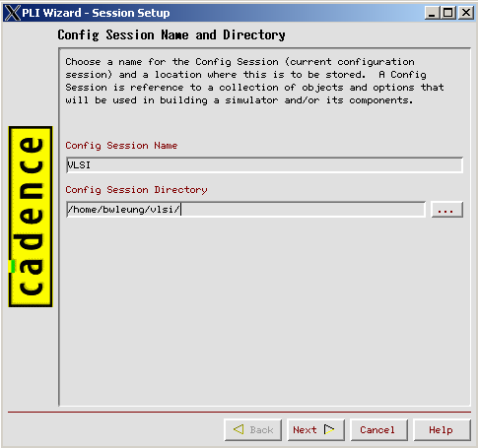
Type in your config session name, and enter your project directory before clicking Next.
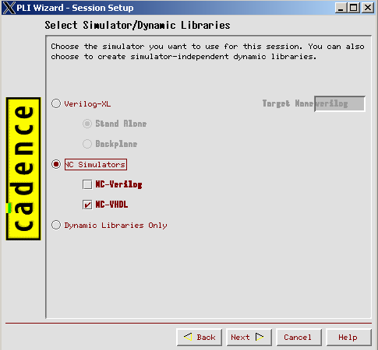
The Simulator we wish to build is NC-VHDL. Check off ONLY that one.
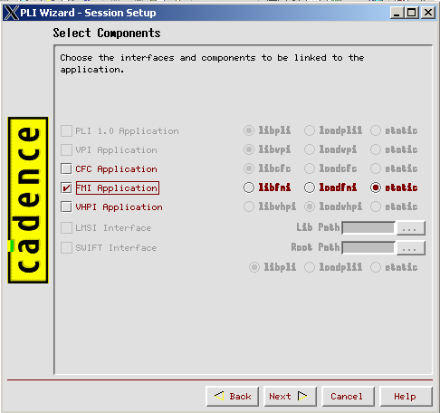
In selecting the libraries we wish to link, check off FMI, and select static, indicating we wish to link the library statically.
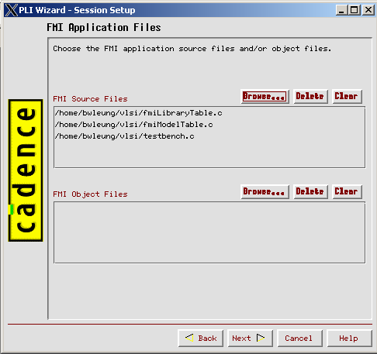
Add all your project files to FMI source files. Leave the object files list blank.
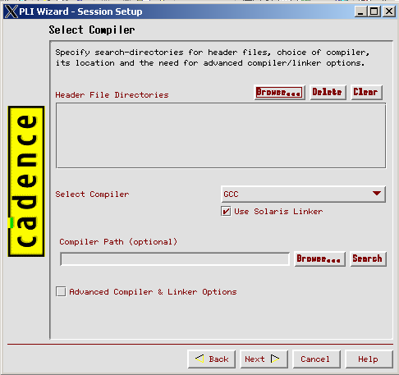
Make sure that GCC is the compiler, and that Use Solaris Linker is checked off. After this step, PLI Wizard will ask if you want to make the target. Say yes and, if there aren’t any weird errors, it will build a new NCSIM executable for you and dump it in the directory you specified.

Compile your VHDL in Cadence
Now that your simulator is re-built, you can proceed with actually compiling the VHDL. The first step is to run it through the Cadence compiler. Go into your project directory and type ‘ncvhdl –V93 –SMARTORDER *.vhd’. If you get an error relating to a missing WORK library, create a new directory named WORK in your project dir.

Elaborate your entity
The next step is circuit elaboration, which attaches VHDL entities to their respective architectures. Do this by typing ‘ncelab –access +r WORK.tb:main’. This elaborates our top level entity, ‘tb’, using the architecture ‘main’. The ‘-access +r’ flag allows you to see the values of each signal during simulation. We’ll get to that in a bit.

Simulate your design
Now you can run your newly built simulator on your design. Do this by invoking ‘./ncsim –gui WORK.tb:main’. If you’re not familiar with UNIX, the ‘./’ at the beginning forces the shell to execute the version of ncsim in your current directory and not the default one, cause that one doesn’t have the C functions built into them.

Add Probes
Once the simulator comes up, go to set → probes and type in ‘:inpixels :outpixels :clk’ into the object field. Check off “Add probes to waveform display” before hitting OK. As long as your entity is elaborated with the ‘-access +r’ flag given, any signal, pin, or variable can be probed during simulation.

Run the Simulation
You can begin simulation of your circuit by typing ‘run 50 ns’ at the simulator prompt. You can run for however long you want, but 50 ns should be enough for this. After simulation completes, you should be able to see your signals’ waveforms in the waveforms display. You should also be able to see the messages that read_bitmap and write_bitmap output to the simulator window. Check your waveform to make sure you’re getting an expected response, and check in your project directory for a file out.txt, that should contain a tab-delimited list of the pixel values. Congratulations! You just successfully simulated your design in Cadence NC-VHDL.

